British Marine / Boating Business Awards Ceremony 2022
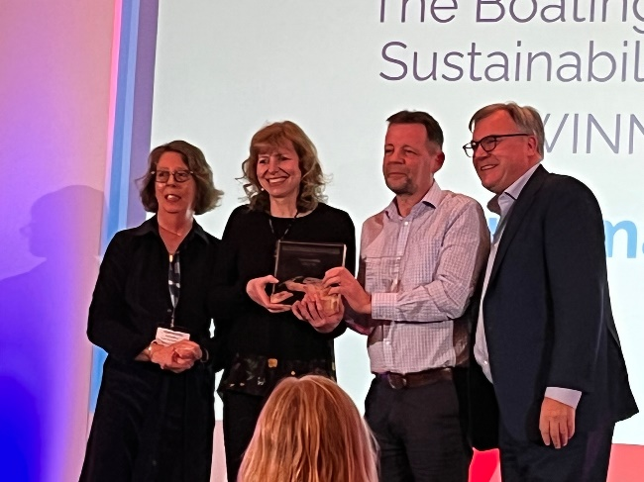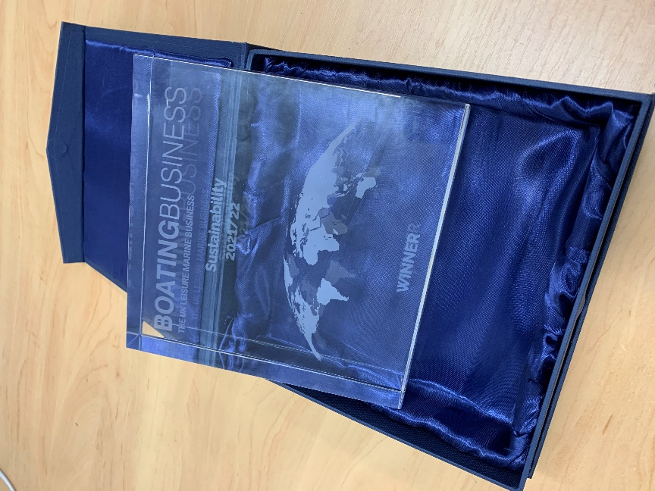
We are very pleased to report that Ortomarine were trophy winners at the annual British Marine Conference held on 15th & 16th March at the National Conference Centre, Birmingham.
We were nominated for the “Business Boating Sustainability Award” which was to be presented to a company that has demonstrated outstanding focus in its environmental and sustainability efforts.
Rob and Caroline attended the Awards Dinner, and were delighted to receive the award from Ed Balls, former shadow Chancellor (and obviously of Strictly Come Dancing fame!)
This is what won us the award – our nomination (not written by us, but by Paul Sumpner who nominated us – a really big thank you to Paul!)
“Ortomarine are a small privately owned UK company, specialising in producing modern narrowboats for use on canals and rivers. Their passion, drive and commitment to producing high quality, beautiful and environmentally friendly boats is setting the standard in the UK inland boat building industry, which is not renowned for embracing new technology and designs.
The owners; Caroline Badger and Rob Howdle are continually pushing themselves to innovate and evolve key areas of the narrowboat interior and exterior design, whilst ensuring that every new owner receives the boat of their dreams, on time and within budget.
Since the first Ortomarine narrowboat was launched in 2015, they now have built over 30 narrowboats, the majority of which have been commissioned by private owners, but also include three all electric trip boats with disabled wheel chair access operated by canal trusts.
Their boats are always highly acclaimed by the canal press and as an owner of one of their recent builds, I can confirm that their quality, design, attention to detail and their pre and after sales support is gold standard.
Ortomarine's goal is to build environmentally friendly boats that both significantly reduce the vessel’s “carbon footprint” and create a quieter, cleaner and more natural boating experience.
Since the launch of their first parallel hybrid powered craft in 2017 (Stray Not Far) they have been encouraging customers to "Go Green" and have now launched 8 parallel hybrids, 3 serial hybrids and 3 fully electric narrowboats.
Their passion for the environment is catching and when our own boat was delayed due to Covid, they opened our eyes to what a modern narrowboat could be, causing us to turn our original specification of a traditional diesel powered, calor gas ovened and dual fuel burner heated narrowboat, on its head. The result was our very own serial hybrid boat (Old Nick), which was wood, coal and gas free. Although it is not currently practical to be completely diesel free and continuously cruise, our reliance and use of diesel was significantly minimised.
The UK narrowboat industry is very traditional and slow to change, but through sharing their own experiences and knowledge Ortomarine, are also encouraging and supporting other narrowboat builders to embrace electric propulsion. They recently organised the world's first Electric Narrowboat Trials Event, where eight Ortomarine boats (3 parallel, 3 serial and 2 diesel) followed an identical course and completed a series of tests (supported by Warwick University and Crown Oils) to show how these different boats performed on a typical canal and river cruise.
By publishing the results of the trials, Ortomarine hope that other boat builders will have the confidence to start specifying and building their own electric boats and are also happy to provide consultancy and supply "Ortomate" their innovative boat control system to other boat builders.
Their commitment to the environment has had a big impact on their business, from the use of electric vans, through to their championing of Hydrotreated Vegetable Oil (HVO), installation of incinerating and composting toilets, a new "Going Green with Ortomarine" branding initiative and their public announcement that they will only accept new orders for boats equipped with some form of electric propulsion.
Ortomarine's boat numbers and size of operation, may be relatively small compared to other boat builders, but their heart and vision is having a big impact in pushing forward the green agenda in one of the most traditional of boat markets.”

https://britishmarine.co.uk/News/2022/March/Winners-of-the-British-Marine-and-Boating-Business-Awards-2022-revealed

